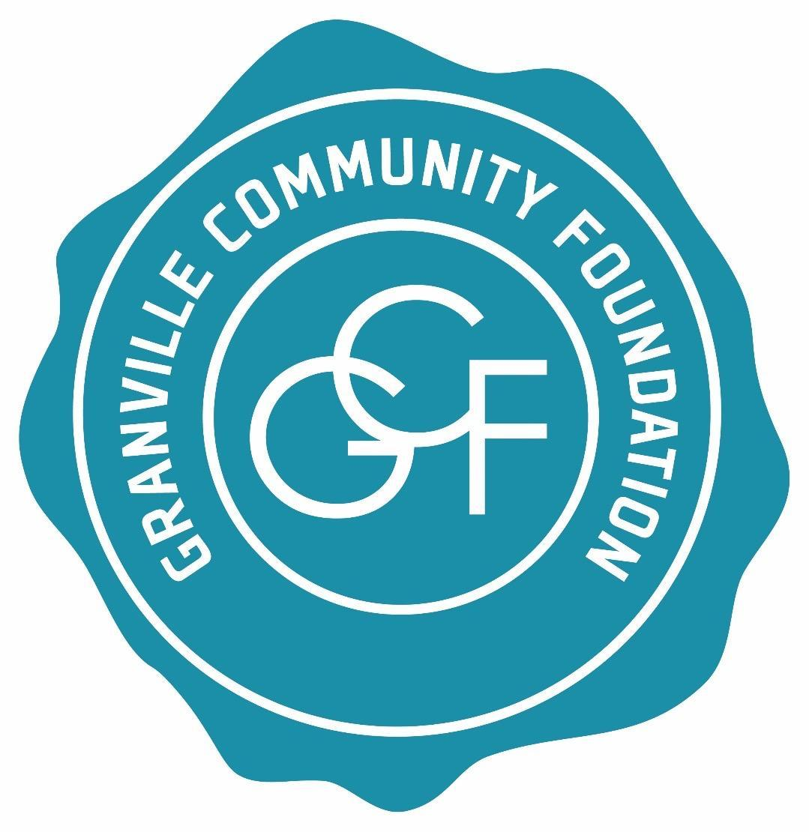

Granville Community Foundation
GRANT APPLICATION GUIDELINES

Revised February 2024

PURPOSE
The Granville Community Foundation was established on May 5, 1971, “…to contribute to charitable purposes for the purposes of the common good, general welfare and civic benefits of the Granville community and to assist in and contribute to such objectives and to movements looking toward the progress and advancement of the Granville community.”
OVERVIEW
At the Granville Community Foundation, our mission is to provide financial support for a broad range of events, programs and projects that touch and enrich the lives of the entire community. Toward this end, the Foundation awards grants to non-profit organizations that support a wide range of community interests in the arts, culture, education, and social services. Funded programs or projects must benefit primarily persons living within the Granville community, defined as the geographic area included in the Granville School District. The Foundation occasionally provides non-competitive grants for purposes meriting special attention.
PRIORITIES: POLICY STATEMENT FOR GRANTMAKING
The Granville Community Foundation funds its grant awards through an endowment built through legacy bequests and an annual fund campaign supported by residents, commercial and non-profit institutions. Decisions about the thrust of the Foundation’s grant program rest in the hands of term-limited directors on a board representing both the community at large and its principal governmental and educational institutions. Decisions are guided by an evolving assessment of community needs. Presently, priority is being given to grant applicants seeking support for projects or programs which address one or more of the following needs:

- Make a clear difference in the quality of life for Granville residents
- Enrich cultural opportunities
- Preserve the community’s history
- Provide residents targeted social support
- Serve the elderly or disadvantaged
- Enhance the attractiveness of public spaces
- Propose innovative and creative solutions to community challenges
- Broaden the life experiences of community youth

CONSIDERATIONS

WHAT TYPES OF GRANT REQUESTS WE ARE LIKELY TO FUND

- Increasing the capacity of nonprofits to respond to community needs
- Start-up costs for new programs
- One-time projects or needs
- Capital needs beyond an applicant's capabilities and means
- Grant proposals that exhibit a diversification of funding sources
- Grant proposals that delineate plans for future funding
- Collaborative projects leveraging the capabilities of multiple organizations
WHAT WE ARE UNLIKELY TO FUND

The Granville Community Foundation cannot respond favorably to all worthwhile causes. In general, we are unlikely to support:

- Academic research
- Annual campaigns, scholarship and endowment campaigns
- Budget deficits
- Debt retirement or restructuring
- Full funding for a program/project is discouraged
- Fund raising
- Feasibility studies for fund raising
- Lobbying activities
- Raffle Tickets or similar games of chance
- Work or projects that have already taken place

The Granville Community Foundation does NOT award competitive grants to:

- Individuals
- Non-secular events or programs
- Private foundations
- Public agencies for mandated services
- Political organizations, events or programs

If you have questions or are unsure whether your project meets our criteria, please contact granvillecommunityfoundation@gmail.com and one of our Grants Committee members will be happy to discuss your proposal with you.

ELIGIBILITY

- Applicants must be: 1) charitable non-profit organizations that have been declared 501(c)(3) public charities by the U.S. Internal Revenue Service; OR 2) Public or quasi-public agencies serving the Granville community. Charitable organizations must have a governing board, and conduct business without discrimination on the basis of race, religion, gender, age, disability or national origin.

- Proposed projects or programs should be designed to benefit primarily persons living within the geographic area included in the Granville School District.

- Programs or projects which benefit some Granville residents but for which the majority of beneficiaries are residents of other communities, may be awarded a “Paid Fees” grant. Please see the end of this document for details.

- Public or quasi-public agencies (e.g., local government, school districts) must be seeking assistance for projects for which government funding is unavailable.

- Programs or projects must be scheduled to take place within 12 months of receipt of award.
MULTIPLE SUBMISSIONS
If you are applying for more than one program or project, please complete a separate application for each program or project. Please rank your projects in order of importance.
INCOMPLETE SUBMISSIONS
Applications that do not contain all the requested information will be denied.
FINAL REPORT
A final report (in a format specified by the Foundation and available at www.granvillecommunityfoundation.com) must be completed and provided to Granville Community Foundation at the earliest date: 1) within 30 days of the event or project completion, 2) before the submission of a new grant application, or 3) January 31, 2025. Unused award funds must be returned to the Foundation along with the final report. Failure to submit a completed report in a timely fashion will disqualify the grantee from receiving a grant from the Foundation in the following year.
2024 ANNUAL GRANT AWARD CYCLE
Spring grant applications available: January 15
Application deadline: February 23
Grant application review period: March 1 – March 31
Grant award announcement: On or before May 1

Grant award reception: November 14 (save the date)
Grantee final report due: The EARLIEST of 1) within 30 days of the event or project completion, 2) before the submission of a new grant application, or 3) January 31, 2025

Fall grant applications available: August 15
Application deadline: September 27
Grant application review period: October 1 – October 31
Grant award announcement: November 5

Grant award reception: November 14 (save the date)
Grantee final report due: The EARLIEST of 1) within 30 days of the event or project completion, 2) before the submission of a new grant application, or 3) January 31, 2025

APPLICATION SUBMISSION
Completed applications should be submitted as follows:
BY MAIL
Granville Community Foundation
PO Box 321
Granville, OH 43058-0321

BY EMAIL
granvillecommunityfoundation@gmail.com (No later than 5:00 p.m. on the application deadline date)

If submitting by email, please attach a single PDF or document. Applications with multiple electronic attachments will be returned.

Paid Fees Grants

Organizations that serve individuals and that charge participation fees may apply for a “Paid Fees Grant.” Paid Fees Grants may only be used to benefit persons living within the geographic area included in the Granville School District who are participating in the specific program for which the Grant was awarded. Awarded Paid Fees Grants will include both a maximum participant amount as well as a maximum award amount. For example: Up to $200 per participant for up 10 participants, for a maximum total of $2000.

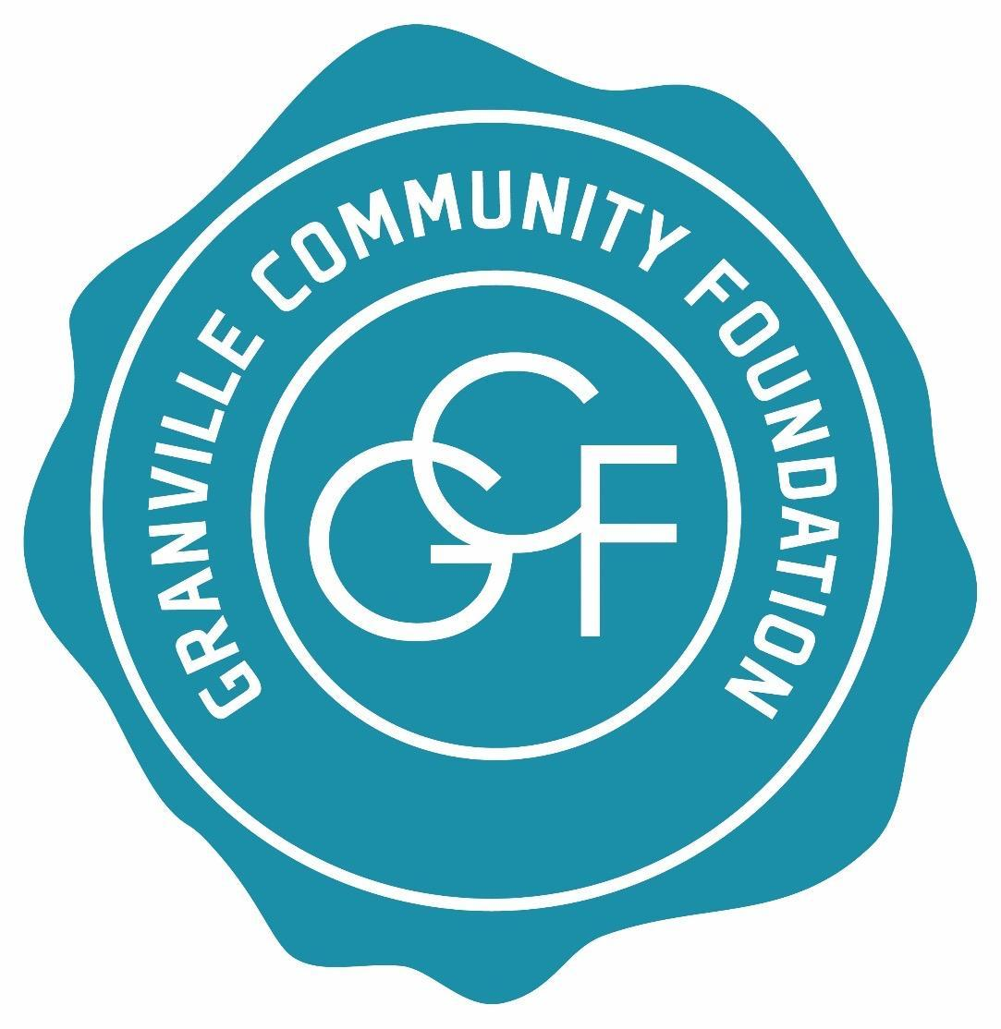

Granville Community Foundation
GRANT APPLICATION FORM
Revised February 2024

Organization Legal Name: ____________________________________________________________
Organization Mailing Address: _________________________________________________________
Contact Name: ______________________________________________________________________
Contact E-Mail Address: ______________________________________________________________
Contact Telephone: _______________________
Name of Project, Program or Event: ____________________________________________________

Please review the revised Granville Community Foundation Grant Guidelines before completing this application. Note: You may include additional pages, as needed, but please keep your responses within the requested word limits for each question. All responses will be kept confidential.

1. Is your organization a legal entity with non-profit 501(c)(3) status? ___ Yes ___ No
Please provide a brief history of the organization (maximum 250 words).

2. Please describe the purpose, goal(s), and objective(s) of the program or project for which you are seeking support (max. 250 words).

3. How will this program or project primarily benefit persons living within the geographic area included in the Granville School District? (max. 400 words)

4. How many people will participate in, or be served or affected by the proposed project?

5. What is the proposed duration of this program or project?
Anticipated start date_______________ Completion date___________________
OR
Date of event__________________________________

6. Budget: provide a budget outlining your program’s proposed expenditures and revenues to help The Foundation fully understand your project and your need for funding. Your response must include the following (max. 250 words):

A. Total cost of the project
B. Itemized expenditures (only required for requests of $5000 or more)
C. Amount of financial support requested from the Foundation
D. Amount of financial support from other sources
E. If awarded, specify how will the Granville Community Foundation funds be used?
F. If awarded, please specify the organization name/person’s name that should be written on the check, as well as the name/title and mailing address of the person responsible for receiving the award check.

7. How will your organization meet its program objectives if it does not receive full funding? (max. 250 words)

8. If you are seeking support for an established program or project, how long has it existed and how has it been funded previously? (max. 250 words)

9. What specific efforts has your organization made to seek funding and in-kind support for this project from its own membership (if applicable) or other sources? Please describe other sources that have been approached and/or have committed funding to the project. (max. 250 words)

10. If this program or project is expected to continue for more than one year, how will it be funded in the future? (max. 250 words)

11. How will your organization collaborate on this project, if at all, with other organizations? (max. 250 words)

12. What specific outcomes must be achieved to determine this program or project as a success? What will be the positive result(s) of your project or program? (max. 250 words)

13. If funds are awarded, please describe how you will communicate that your organization has received support from the Granville Community Foundation, (i.e. press release, social media, printed program material, etc.). (max. 250 words)

14. After reviewing the grant guidelines, please provide any other information that you consider pertinent to your grant request here. (max. 250 words)

15. All Granville Community Foundation grant recipients are required to submit a final report on the accomplishments of the funded program or project. Please identify the person who will be responsible for fulfilling this requirement on behalf of your organization together with his/her contact information:

16. CERTIFICATION OF INFORMATION:
Name of organization head: _____________________________________________________
Signature of organization head: __________________________________________________
Date: _________

